Assigment No 7

1)) Write a query that counts all orders for October 3.

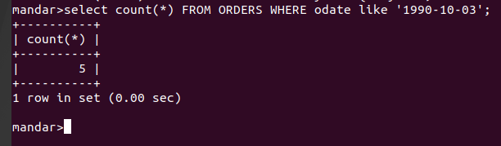

2) Write a query that counts the number of
different non-NULL city values in the Customers
table.
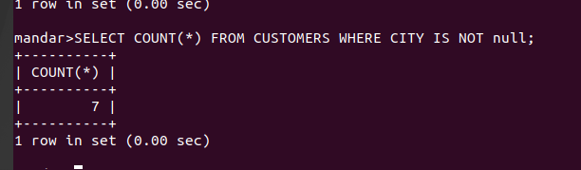

3) Write a query that selects each customer’s
smallest order.

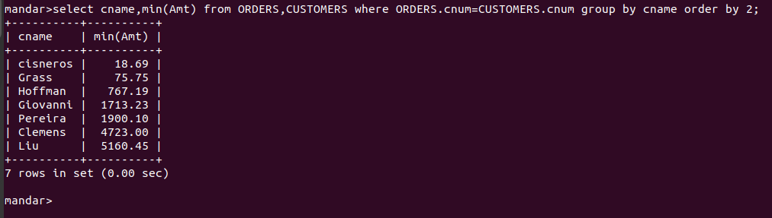

4) Write a query that selects the first customer,
in alphabetical order, whose name begins with G.
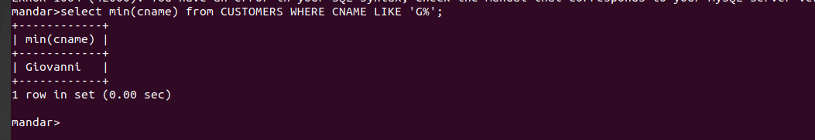

5) Write a query that selects the highest rating
in each city.

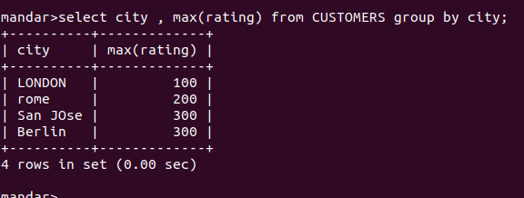

6) Write a query that counts the number of
salespeople registering orders for each day. (Ifa
salesperson has more than one order on a givenday,
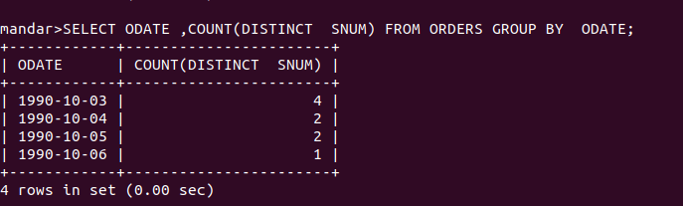
he or she should be counted only on

